

London property market

An analysis of clusters of London neighbourhoods and their respective prices



May 18, 2020

Syed ahmad

**Context:**

The city of London was built in the year 43 AD by the Roman empire and is a city rich in history and geographical diversity. It has seen wars, plagues, fires and most recently a virus pandemic. As the capital city of the United Kingdom, it is home to 9 million residents and is a global hub for commerce and culture. Each year the city attracts tens of millions of visitors who come to marvel at historic sites such the Tower of London and Buckingham palace. The population of the city continues to grow each year as it attracts many migrants from around the world, in search of employment and a cosmopolitan lifestyle.

However, for all its charm the city has a fundamental problem. There is a severe shortage of housing in the city, and current supply is unable to keep up with the growth in demand.

The city is surrounded by two circular ring roads and a river which runs right through the heart of the city. Much of the infrastructure which supports the city was build centuries ago, and although it plays a key role in the modern world, the city stands on ancient foundations. To complicate this further, large parts of the city were either destroyed completely or badly bombed during the second world war.

Due to the high levels of investment, neighbourhoods are constantly being redeveloped and changed, new bars and restaurants open on a weekly basis, and glitzy penthouse apartments stand next to centuries old manor houses. This has created a challenging situation for those looking to enter the London property market, as affordable neighbourhoods are gentrified, and local residents are priced out.

**Problem:**

Due to the international investment and the high levels of demand for housing, the challenge faced by many of London’s inhabitants is the inability to afford to live in the very city they work in. When choosing a location to live, various factors come in to play depending on the individual. Some may be looking for a neighbourhood with lots of bars and restaurants, and a busy nightlife scene. Others may be looking for parks and outdoor spaces.

In this analysis I will cluster London neighbourhoods based their local features. The feature dataset will be obtained using the foursquare API service to extract a list of the venues nearby. This dataset will be used to group areas by their geographical similarity. I will also bring in data on house price transactions in the local area to understand local house prices and compare this for the different neighbourhoods.

The problem I aim to solve in this analysis is to identify the more affordable neighbourhoods that offer the same local venues and services as others. This will help anyone who lives in the city, or is looking to move to the city, find an affordable neighbourhood. Given the rapid rate of change in London, this will help those living in the city keep up with the changes and find affordable accommodation without compromising on their standard of living.

**Data:**

**London geospatial data** – In order to correctly identify the various different Geographical layers in London, I will require data on the latitudes and longitudes of each polygon. This dataset will be extracted from a .csv file available on the website <https://www.doogal.co.uk/london_postcodes.php>

**Foursquare data** – The foursquare api will be used to retrieve data on the characteristics of each neighbourhood. The data will retrieved using specific latitudes and longitudes corresponding to each area. This data will form the features dataset that will be used to cluster each neighbourhood.

**Transaction data from HM land registry** – In order to understand local house prices I will need data on UK house transactions. I will obtain this from the official government records at HM land registry found at: <http://prod.publicdata.landregistry.gov.uk.s3-website-eu-west-1.amazonaws.com/pp-2020.csv>. This data set includes a list of transactions across the United Kingdom since the start of 2020.

**Methodology:**

1. Obtaining geospatial data for London neighbourhoods:

Data Cleaning:

I downloaded a .csv file which I read directly into a pandas dataframe which contained a large amount of information on London neighbourhoods. This data source had a huge amount of information, some of which would be relevant for further analysis, and other sections that were less relevant. I filtered out the columns that I would not need and held onto only those that would be relevant for the clustering analysis.

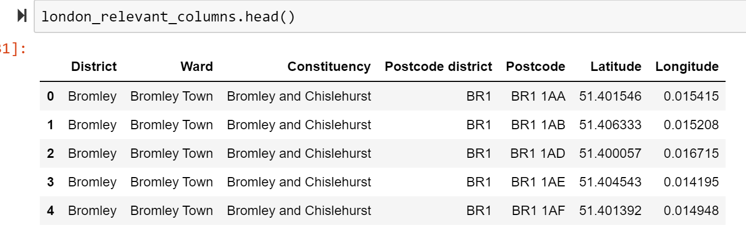

Figure 1: Geospatial data on London

This data gave me latitudes and longitudes of each specific postcode and was far more detailed than I required. I used the groupby method to aggregate this data at the postcode district, constituency and district level. Taking the mean of the latitudes and longitudes to give me centroid coordinates of the different geographical layers. The resulting output is shown below:

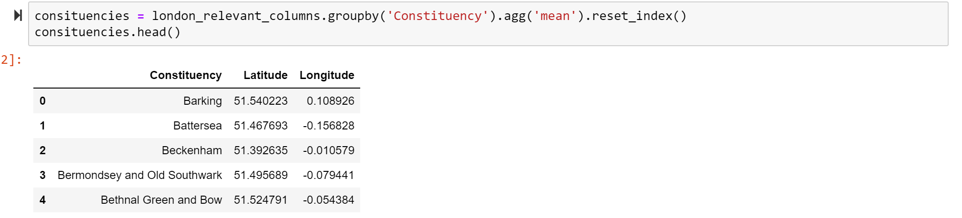

Figure 2: Grouped geospatial data

Exploratory data analysis:

In order to understand the geospatial characteristics of each of these layers, I visualised each one using the folium maps library in python.

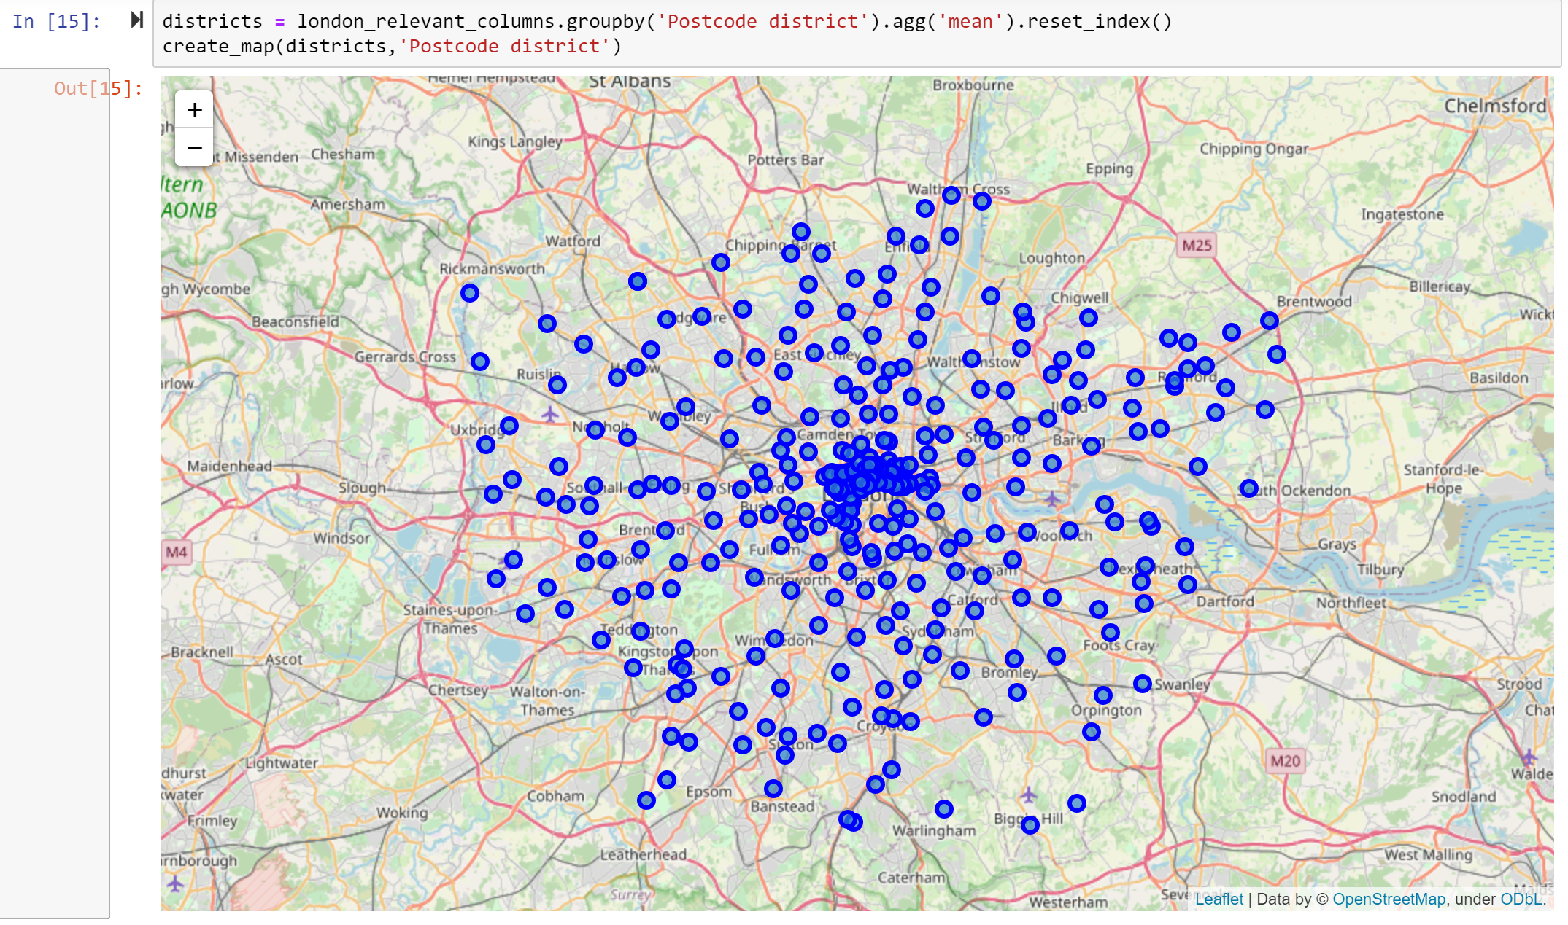

Figure 3: Geospatial data points at postcode district level

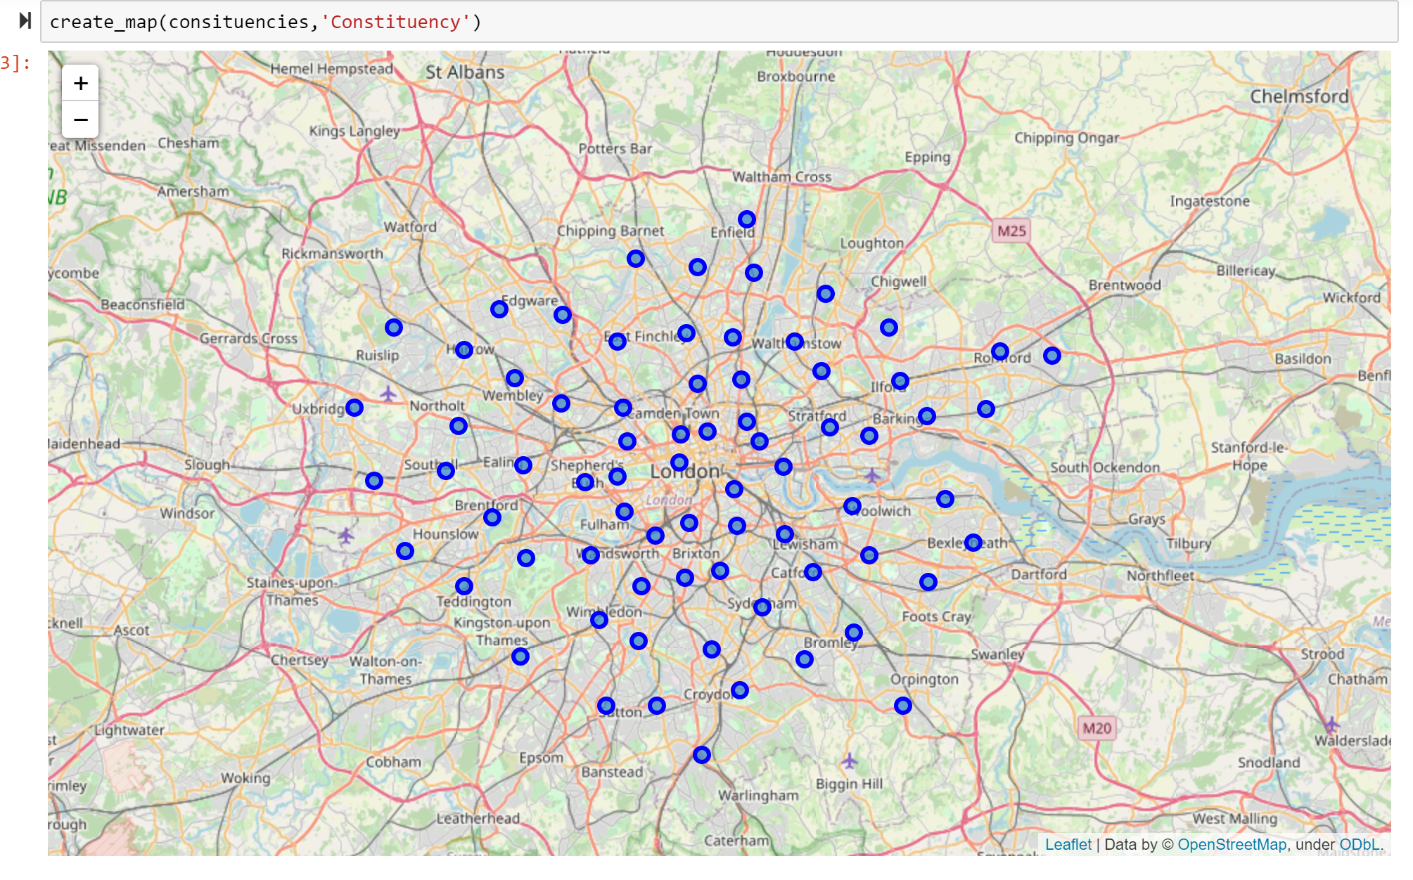 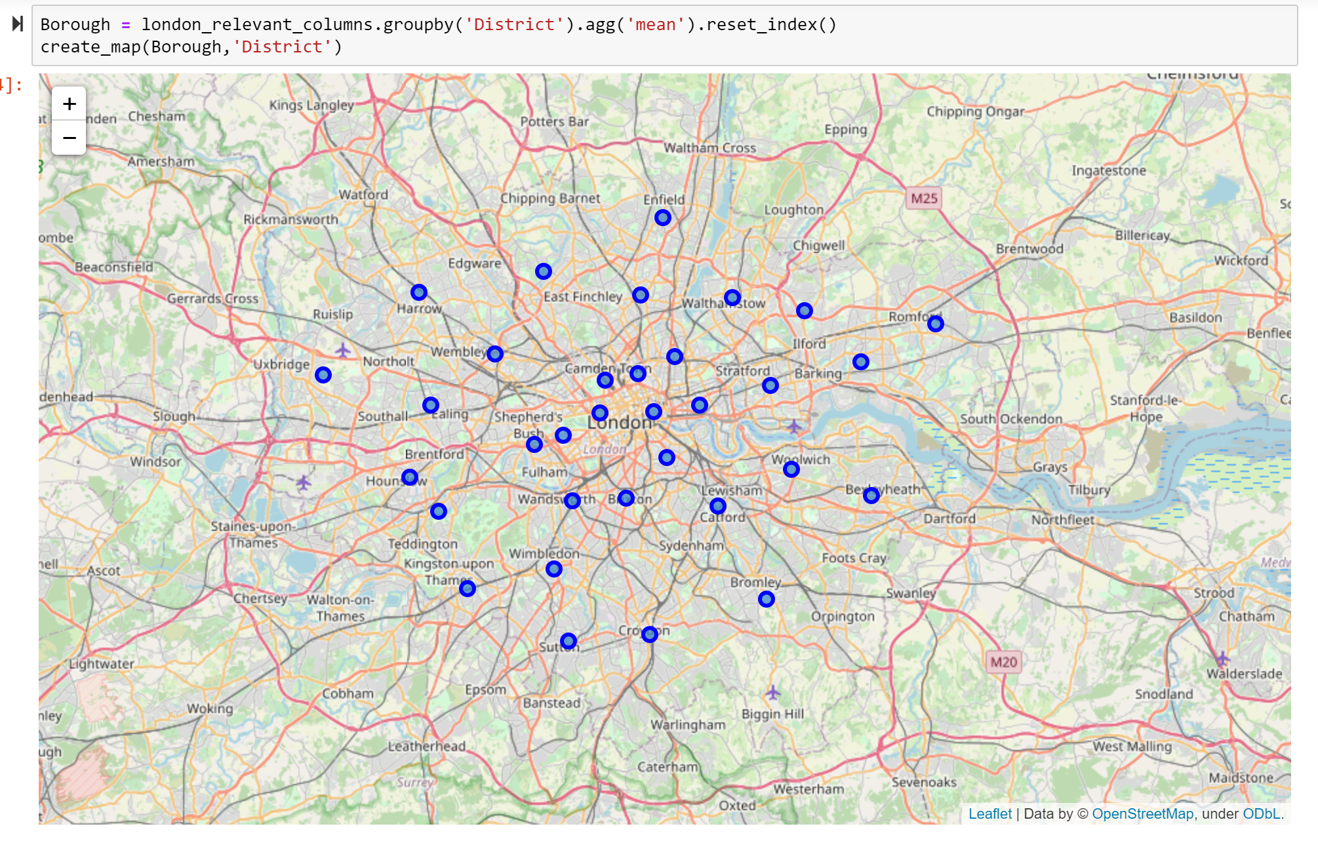

Figure 4: Geospatial data points at constituency level Figure 5: Geospatial data points at district level

Conclusion:

The images above show us that ‘District’ level geographical layer is unsuitable for this analysis since there are very few datapoints to provide reliable information. The geographical distance of each data point will result in many of the features of the geographical layer being missed out.

The postcode district layer will give us more granular detail on the individual characteristics of a neighbourhood and is more likely to capture the differences between neighbourhoods. However, we can see there is a bias in the dataset due to the geographical proximity of data points in central London, vs those is the outer parts of the city.

The constituency layer appears to provide the most evenly distributed dataset. However, due to domain knowledge of the local area, my concern is that this layer will not capture the individual characteristics of each neighbourhood. **As a result, the subsequent analysis is carried out at the postcode district level and repeated for the constituency layer. I will also carry out further data cleaning to mitigate the bias in the postcode district dataset.**

1. Obtaining average London House prices:

Data cleaning:

I obtained detailed data from HM government land registry office, on each property transaction that took place in the UK in 2020. The data can be found at this URL. This provides us with data on house purchases in 2020, and includes the address of the property, price paid for the property and the date of the transaction. A sample of this data is shown below:

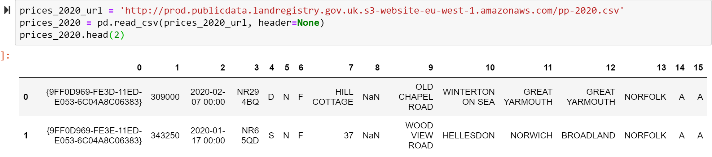

Figure 6: Transaction data from HM land registry

The data in this table contained information on all UK transactions, however this analysis is only concerned with property transactions in London. So, I filtered the data frame on column 13 for ‘GREATER LONDON’.

In order to find average house prices for an area, I needed to aggregate this data at the same geographical layers as present in the geospatial dataframe. From the table above we can see that the ‘Postcode’ field is present in both data sets (Column 3 above). I used a join method to combine the two dataframes, to give me transactions and the corresponding geographical layer of property, resulting in the following output:

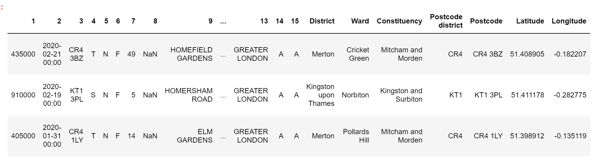

Figure 7: Geospatial data with transactions

I was then able to group these transactions at each layer taking the mean of transactions within the layer.

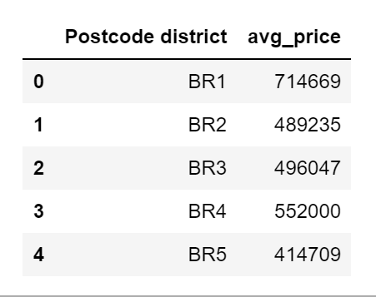 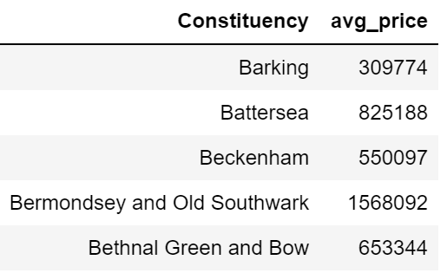 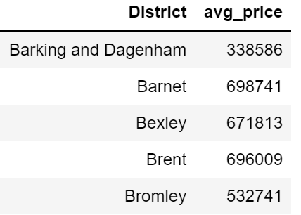

Figure 8: Average house prices by geographical layer

Exploratory data analysis:

In order to be understand the distribution of property prices across London, I created a histogram plot at each layer.

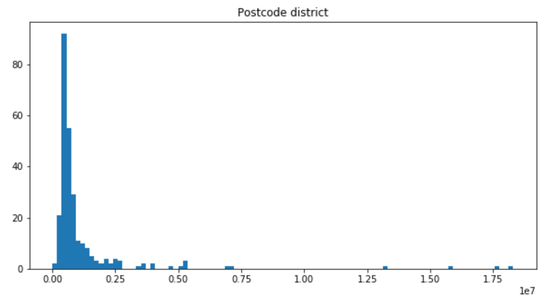

Figure 9: Distribution of property prices at postcode district level

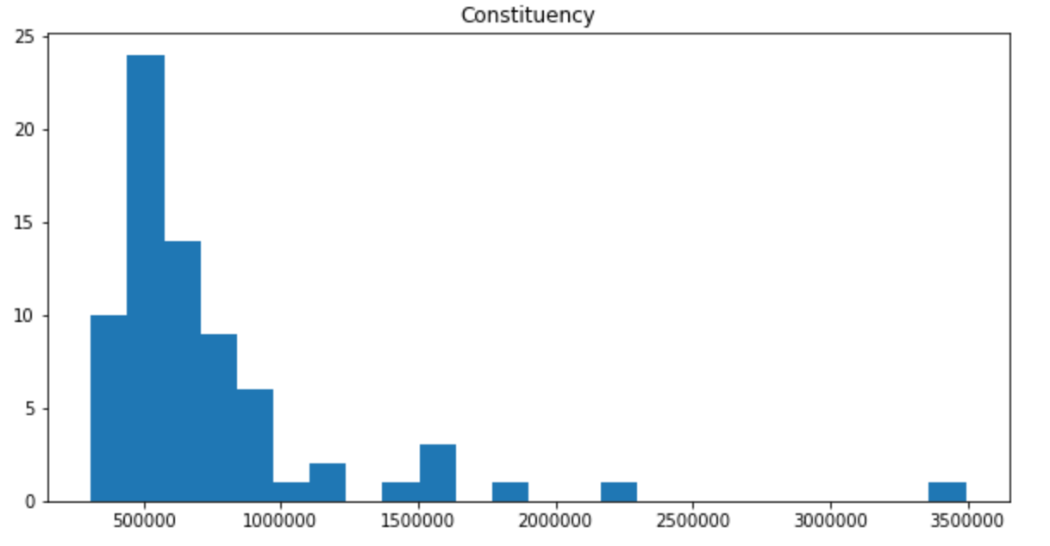

Figure 10: Distribution of property prices at constituency level

Conclusion:

The charts above show us that property prices across London follow a fairly normal distribution, with a long tail and a skew towards higher values.

This is as expected given the high premium that prime central London real estate receives and the limited space in the city.

Based on the above the areas can be classified into four categories, Cheap, Mid range, premium and expensive.

1. Using foursquare API to get data on local venues

Data extraction

With the latitude and longitude coordinates for the area centroids, I was able to call the ‘explore’ endpoint of the foursquare API to get a list of the local venues within a 500-metre radius of the area. I started off with the coordinates for each postcode district and extracted the corresponding feature dataset.

Results

The resulting dataframe is shown below:

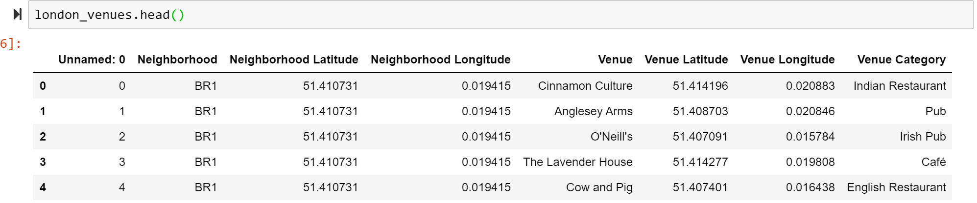

Figure 11: Foursquare API output by postcode district

The API call produces a dataset of 11,150 rows with 385 unique venue categories. The venue category is the column that will be used for the clustering algorithm and forms the feature dataset. This corresponds to 385 unique features that the algorithm would have to process. This is very large number of features for relatively small number of neighbourhoods. **As a result, I determined that I may need to carry out some feature engineering for the clustering to work effectively.** However, the preliminary approach would be carried out without any feature engineering to gauge its impact.

1. Clustering the feature data set using Kmeans clustering algorithm

Data preparation:

The foursquare data provided me with a very comprehensive data set of features, however this data was all in the form of categorical variables in text strings. The Kmeans clustering algorithm creates clusters grouped by the similarity within a cluster, and the dissimilarity between clusters, using the Euclidean distance between data points. As a result, the algorithm is unable to deal with categorical features and this would have to be pre-processed and converted into numerical variables.

A common approach for converting categorical data into numerical is using one hot coding. One hot encoding converts categorical data into binary values of ‘0’ or ‘1’. Each unique feature or variable is given its own column and the presence of a ‘0’ or ‘1’ indicates that the variable is present or not for that datapoint. In this dataset, given there are 385 features, this would create a dataframe of 386 columns.

The pandas python library has a predefined function that uses one hot encoding to convert categorical data into numerical variables, this is called using ‘pandas.get_dummies(*categorical data*)’. I used this method to convert the ‘venue_category’ column of the venues dataframe into numerical data. Once converted I was able to group the data by postcode district using the mean of the frequency of variable occurrences. The resulting dataframe is below:

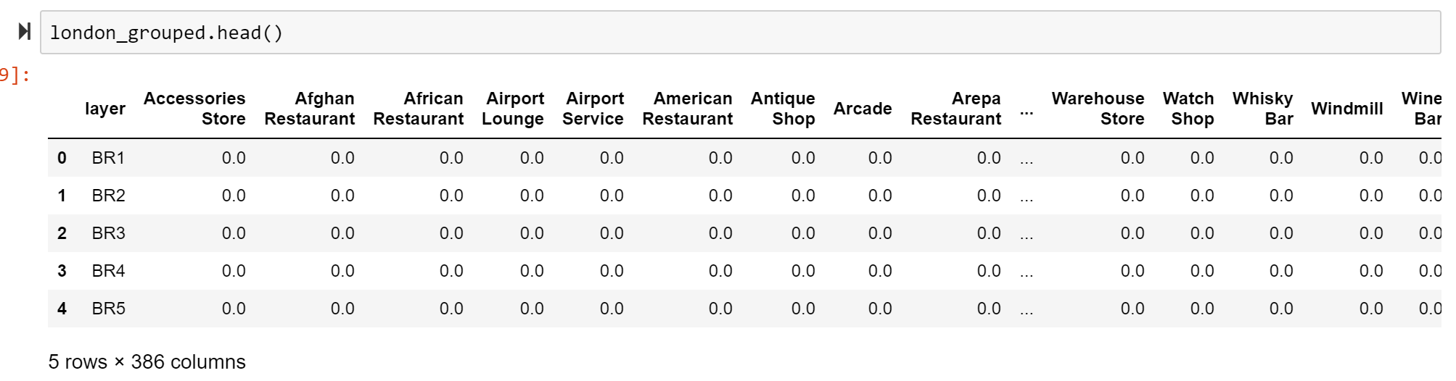

Figure 12: One hot encoded venue data grouped by postcode district

In order to aid visualisation of what this means for each of our areas, I then converted this aggregated encoded, back into categorical data ordering each row by horizontally to show the most common venues in each neighbourhood.

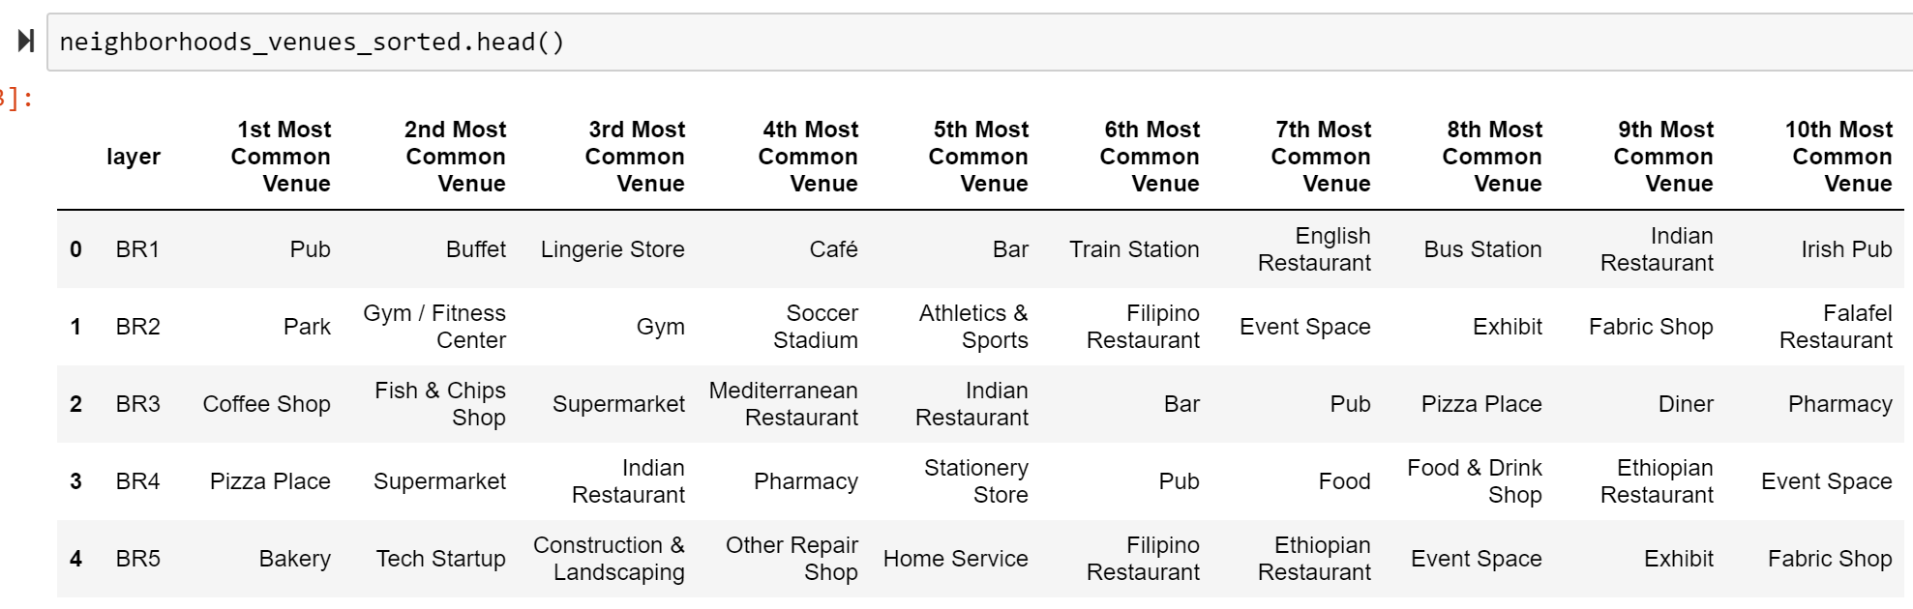

Figure 13: Most common venues for each postcode district

Model training and optimisation:

In order to use the clustering algorithm, I would have to determine the optimum number of clusters for the model to identify (K). The elbow method is one technique that can be used to determine this. The elbow method shows the distortion of values on the y-axis and the K value on the x-axis. As K increases, the chart should show a decrease in the distortion of values, until the optimum K is found, at which point an increase in K would have a negligible effect on reducing the distortion. The elbow method is named as such, because the chart should display a sharp bend at the point which describes the optimum K (resembling an elbow).

Results:

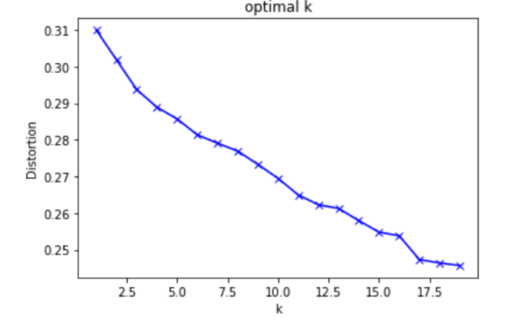The results of my elbow method analysis can be seen in the Fig 14. The k value does not show a sharp bend at the optimal K, instead we observe a linear relationship between K and distortion, indicating that incremental increases in K will continue to deliver additional benefits to the model accuracy. This may be due to the fact that this dataset has a very high ratio of features to datapoints, which is affecting model performance. **This provides further support to the theory that the feature data set may require additional feature engineering before model training.**

Figure 14: Elbow method for clustering postcode districts

Due to the inconclusive nature of the elbow method, I carried out further analysis to determine the optimal K. I plotted a histogram showing the frequency of each cluster to understand how well the algorithm was able separate areas. Results shown below:

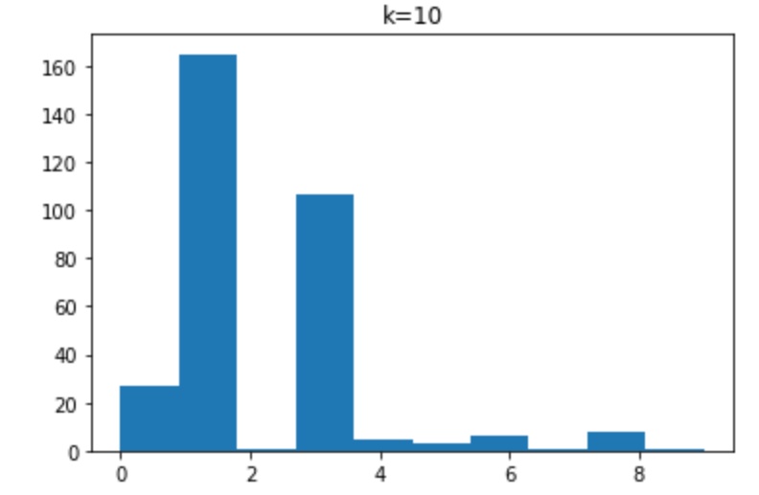 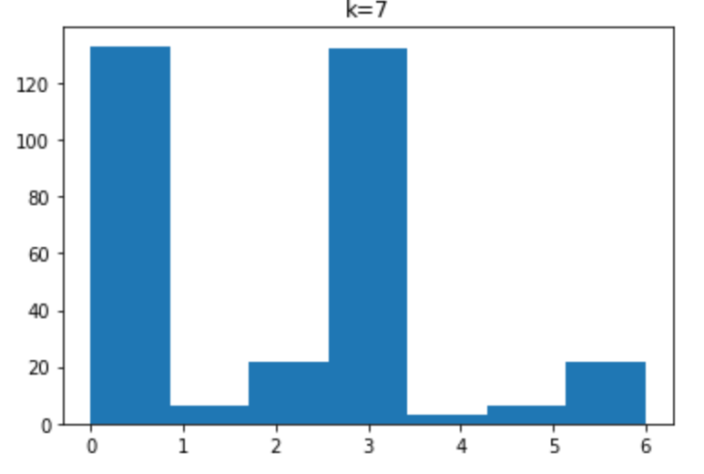

Figure 15: Histogram of clusters by postcode district

Although the elbow method indicated that a higher K would be better for the algorithm, I decided to use K as 7 due to the fact the analysis above showed that using 7 clusters would create additional separation that was not replicated when using 10 clusters. I wanted to see how the model would group these features, and the second plot indicated more data points within clusters, even though there were fewer of them. I suspected that a higher K was overfitting the data which is what we see from the first histogram.

Exploratory data analysis

I then retrained the model using K=7 and visualised the clusters using the folium maps library in python:

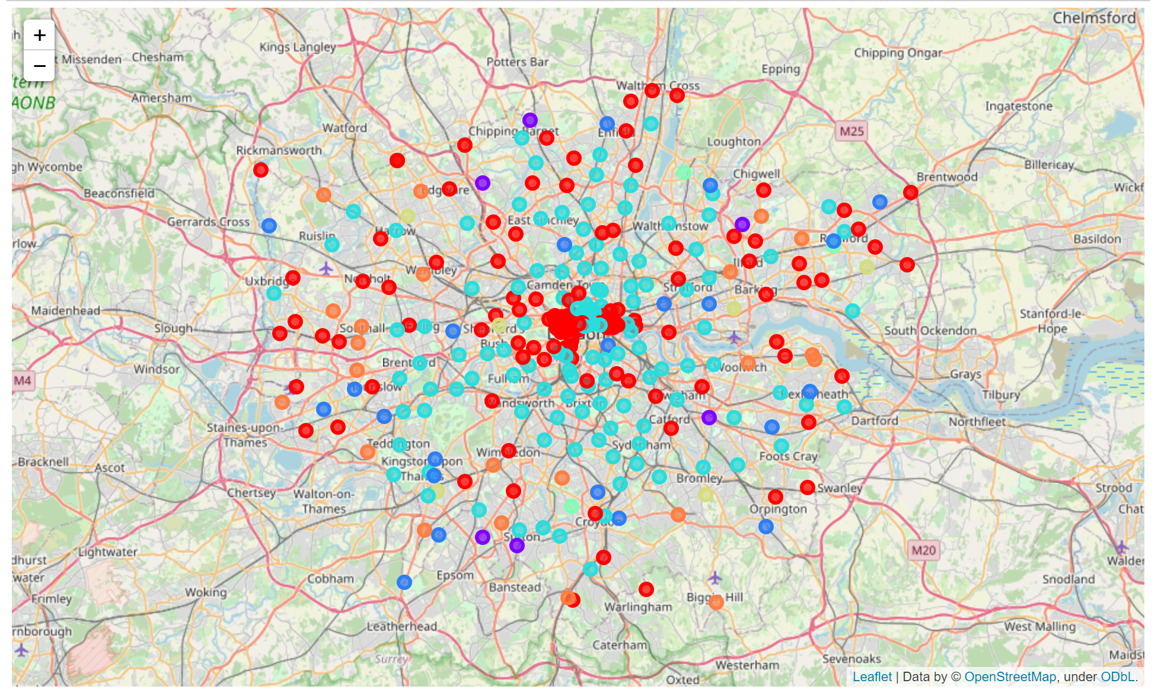

Figure 16: Map of clusters by postcode district

The geographical diversity of the clusters indicates that there may be some insights we can draw from this dataset. I joined the average house price data to my dataset of area clusters to see some additional detail on the clusters and identify any under-priced areas. Resulting in the dataframe below:

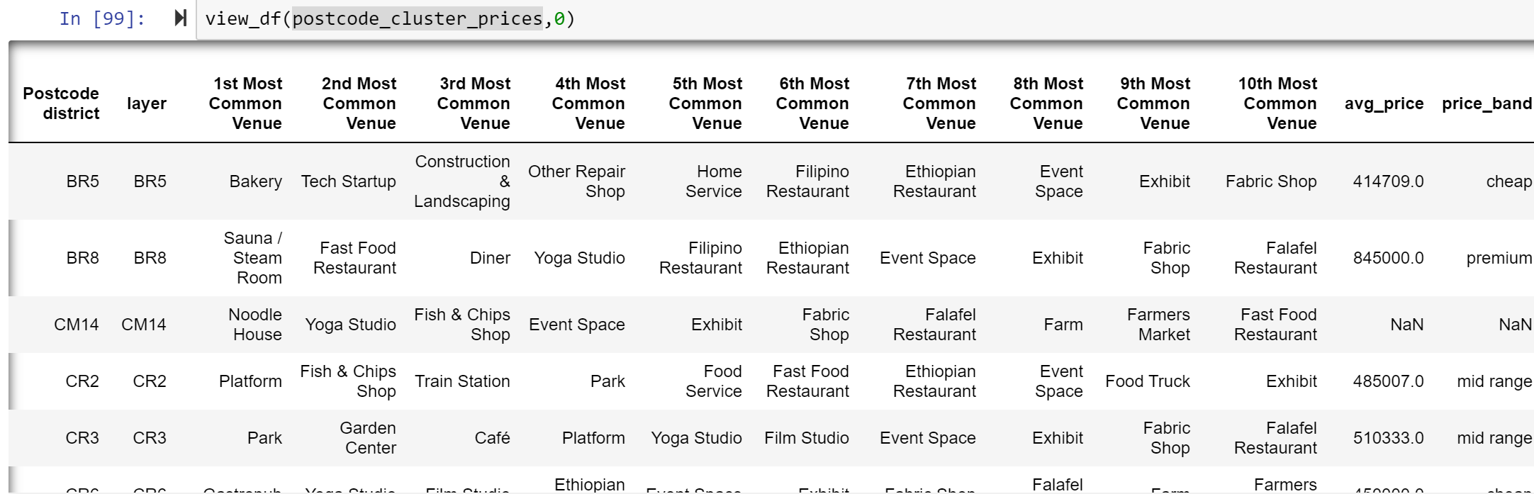

Figure 17: Output dataframe of postcode clusters

There is a lot of data here, but this can be summarised using the dataframe stack and value counts method for each cluster. In doing this, we can see what type of venues are most prevalent in each cluster.

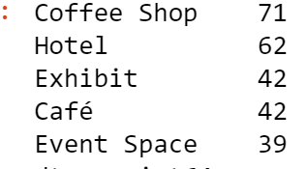 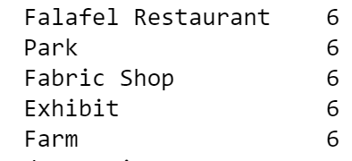 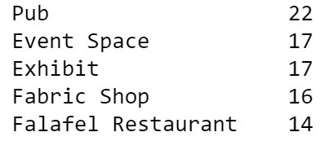

Figure 18: Top 5 value counts for cluster 0,1 and 2 (left to right)

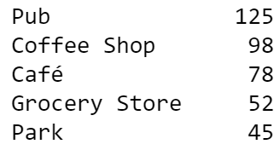 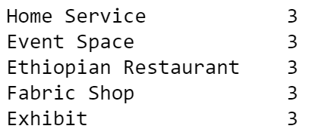 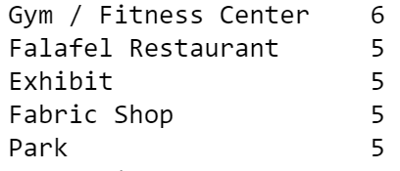

Figure 19: Top 5 value counts for cluster 3, 4, 5 (left to right)

The data above shows that the algorithm was able to identify some distinct features for various groups of neighbourhoods and was able to group these together by similarity. We categorise some of the clusters according to the following: Cluster 0 – Hotels, Cluster 1 – parks, Cluster 2 – pubs and exhibitions, Cluster 3 – pubs, Cluster 5 – gyms and outdoor spaces.

Figure 17 also shows that the analysis was able to identify cheaper neighbourhoods that provide the same local amenities and services as some of the other more expensive ones.

Conclusion:

We have identified a number of clusters we can group together; these clusters may serve more active types who require a neighbourhood with lots of outdoor spaces and gyms or young professionals looking for more pubs and cafes.

**However, we know from the results of the elbow method test that we can improve the clustering further by reducing the number of features in the dataset.** The next iteration of this analysis will seek to achieve this.

1. Feature engineering the dataset at postcode district level

Data cleaning:

As we saw earlier, the current feature dataset has 385 unique values, resulting in 385 different features which the model must calculate distance for. Given we have 329 different postcode districts this results in a high ratio of features to data. Reducing the number of these features is likely to improve model performance.

Upon inspection of the features, I noticed that many of the features were very similar. For example, there were 80 different variables for restaurants for each different type of cuisine (Italian, Mexican, French etc.), 15 for bars, 45 for shops, 35 for stores, 6 for gyms, 9 for food places and 4 for museums. I grouped these variables by a common category and in doing so I was able to reduce my features down from 385 to 198.

Results:

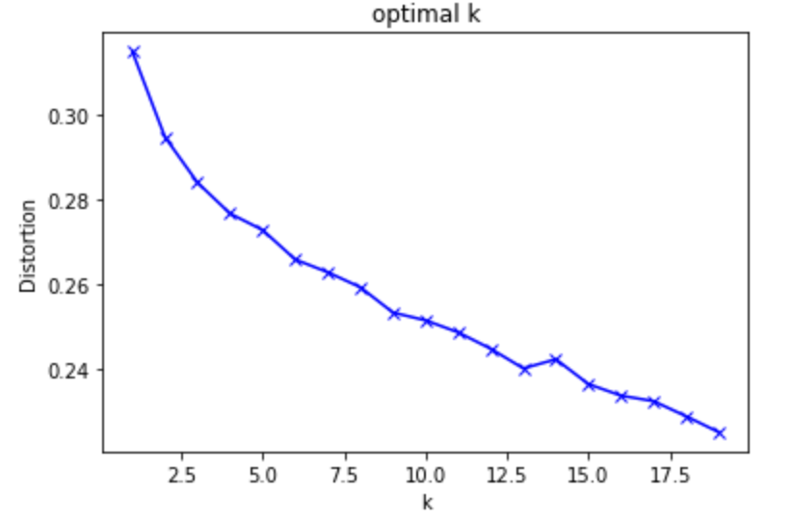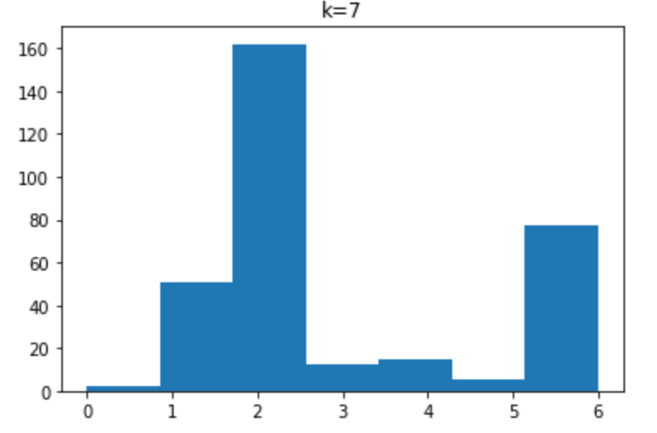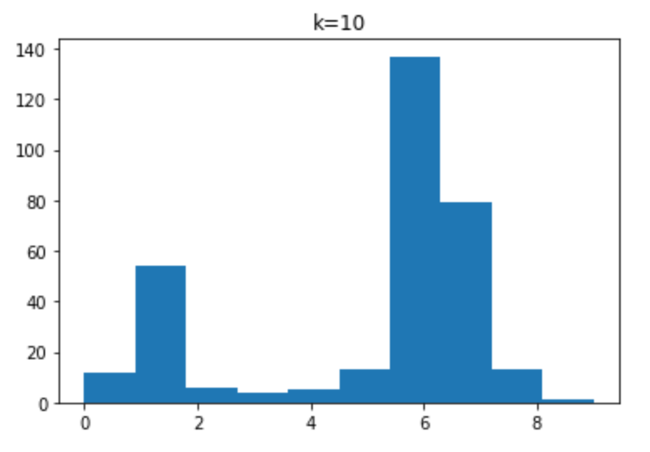

Figure 20: model optimisation after feature engineering

We can see from the chart above on the left-hand side, that although we still do not see a sharp bend indicating the optimum K, we can see more of a curve compared to previous iteration. This indicates that the feature engineering has had some success in improving model performance. Based on the analysis above I opted to use k = 10 for training the model as this looked to be point where the gradient was flattening out and any higher values of K may result in overfitting. The resulting clusters from the model are shown below:

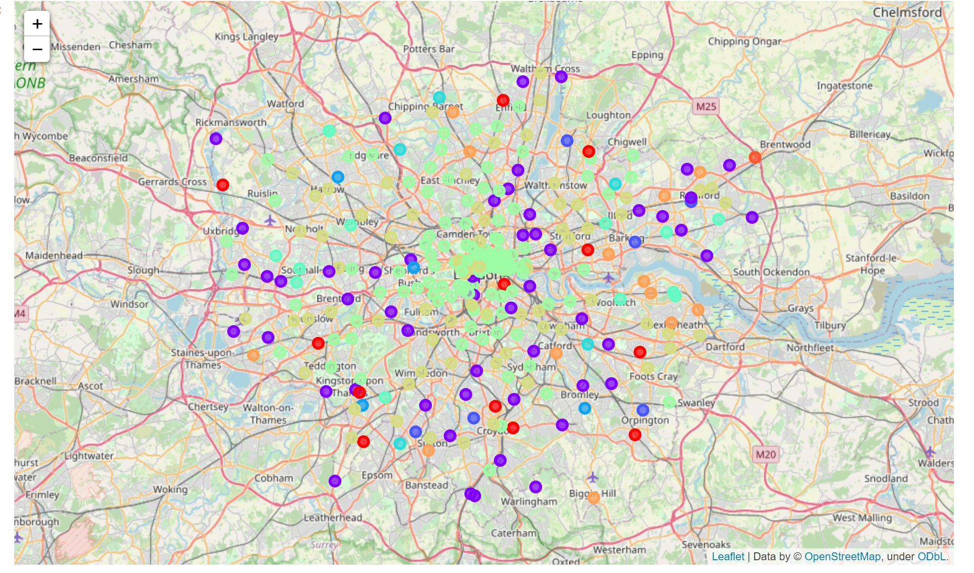

Figure 21: Clusters after feature engineering

|  |  |  |  |  |
| --- | --- | --- | --- | --- |
| **Cluster** | **Map legend** | **Features** | **Suitable for** | **Affordable options** |
| Cluster 0 - Suburbs | red marker on the map | pubs and markets | Perfect for families | CR |
| Cluster 1 – Trendy villages | Purple | Pubs, Art galleries, parks and Film studios | Perfect for mid-career professionals | RM, E3, SE9 |
| Cluster 2 – Industrial parks | purple/ blue colour | construction and landscaping facilities | perfect for self-employed tradesmen | All Cheap |
| Cluster 3 – Active neighbourhood | Dark Blue | Gyms, parks, stadiums | Active types | HA3 |
| Cluster 4 - Markets | Blue | Markets | Anyone | All mid-range |
| Cluster 6 - Nightlife | Green | Restaurants, bars, hotels | Young professionals / Tourists | E16, EC2M |
| Cluster 7 – Shopping district | Yellow | Restaurants, Shops | Tourists | TW4, KT9 |
| Cluster 8 – outlet stores | Orange | Large stores | Families | DA, SE2, TN16 |

Figure 22: Clustering of London areas

The table above shows the distinct areas and a summary of the features of each. We can see that there are a variety of options for many different groups. In addition, the last column identifies the cheaper areas within those categories, so that one may find the area and local amenities they require within their price range.

1. Analysing the impact of bias in the postcode district dataset

As we saw initially in figures 3, 4 and 5, there is an inherent bias in the dataset when classifying the areas at the postcode district level, due to the geographical proximity of the points. However, we also saw above that having a high feature to data ratio can be detrimental to model performance. One option for reducing the bias in the dataset would be to carry out the analysis at a higher geography layer, such as the constituency level. However, this would result in a fewer number of geography data points and as a result would result in a lower feature to data ratio. Therefore, on the one hand the higher layer aggregation may mitigate bias in the dataset, but on the other hand the reduced data set may reduce model accuracy. The analysis is repeated here at the constituency level to evaluate if any incremental improvements to classification can be gained. The results of this are shown below:

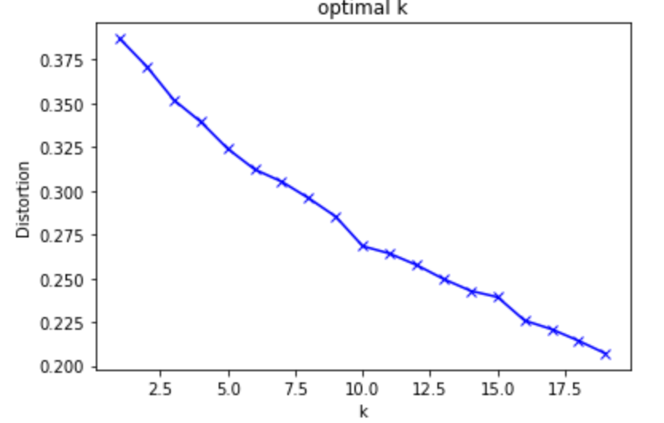 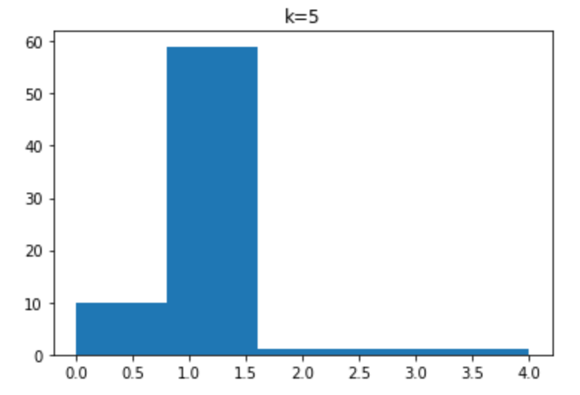 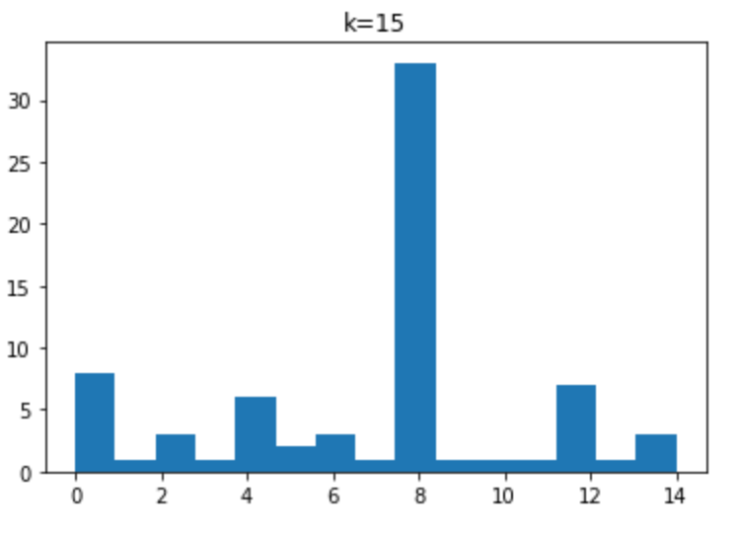

Figure 23: model optimisation at constituency level

**We can see from the charts above that the higher-level aggregation does not improve clustering, it worsens this.** The elbow method chart on the left shows a more linear curve, indicating no optimal K. and the histogram plots show very few data points within the clusters indicating poor separation of features. One explanation for this may be the fact that at a higher layer geography, the impact of local nuances in an area is evened out, and as a result all geographies appear too similar to distinguish features.

**Summary & Conclusion:**

The analysis above has provided us with valuable insights into understanding the London property market. The main conclusions we can draw from the data are the following:

* There is an inherent bias in datasets concerning London property, due to the fact that neighbourhoods in the centre of the city are a lot closer to each other than neighbourhoods in the outskirts
* House prices across London follow a normal distribution with a long tail and skew towards much higher values for prime central London real estate
* Due to the highly varied and diverse nature of neighbourhoods in London, clustering based on types of venues alone has limited impact and feature engineering is required to improve the Kmeans clustering algorithm

We have also gained valuable insight into the nuances of different neighbourhoods in London, we can categorise these neighbourhoods according to the following: Suburbs, Trendy villages, Industrial parks, active neighbourhoods, markets, nightlife centres, shopping districts and large outlet stores. We have also identified a number of cheaper neighbourhoods within these categories based on the distribution of London property prices. This will aid future home buyers, or existing London residents to find affordable accommodation in the city.

|  |  |  |  |  |
| --- | --- | --- | --- | --- |
| **Cluster** | **Map legend** | **Features** | **Suitable for** | **Affordable options** |
| Cluster 0 - Suburbs | red marker on the map | pubs and markets | Perfect for families | CR |
| Cluster 1 – Trendy villages | Purple | Pubs, Art galleries, parks and Film studios | Perfect for mid-career professionals | RM, E3, SE9 |
| Cluster 2 – Industrial parks | purple/ blue colour | construction and landscaping facilities | perfect for self-employed tradesmen | All Cheap |
| Cluster 3 – Active neighbourhood | Dark Blue | Gyms, parks, stadiums | Active types | HA3 |
| Cluster 4 - Markets | Blue | Markets | Anyone | All mid-range |
| Cluster 6 - Nightlife | Green | Restaurants, bars, hotels | Young professionals / Tourists | E16, EC2M |
| Cluster 7 – Shopping district | Yellow | Restaurants, Shops | Tourists | TW4, KT9 |
| Cluster 8 – outlet stores | Orange | Large stores | Families | DA, SE2, TN16 |

Recommended further analysis:

In order to mitigate the impact of the bias in the dataset, one could clean the postcode district data and carry out the analysis on this layer. This is explored further in the accompanying notebook to this analysis.